HOW TO PRINT

IPAD

- Open file: Press on share icon button then press print
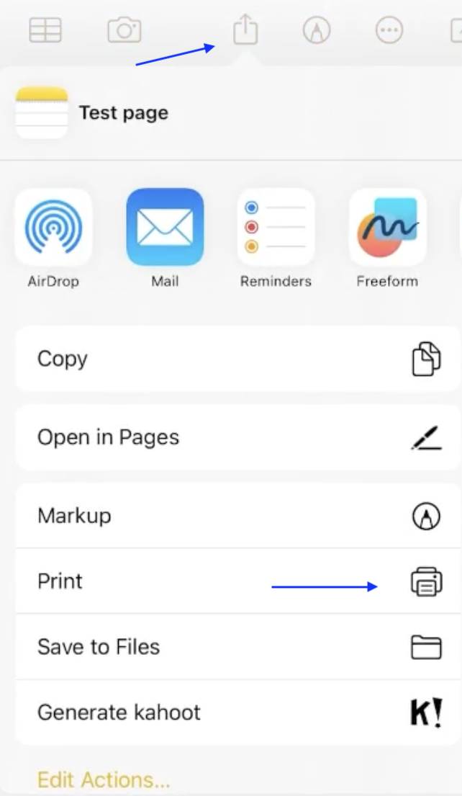

- Printer options: Press on Printer
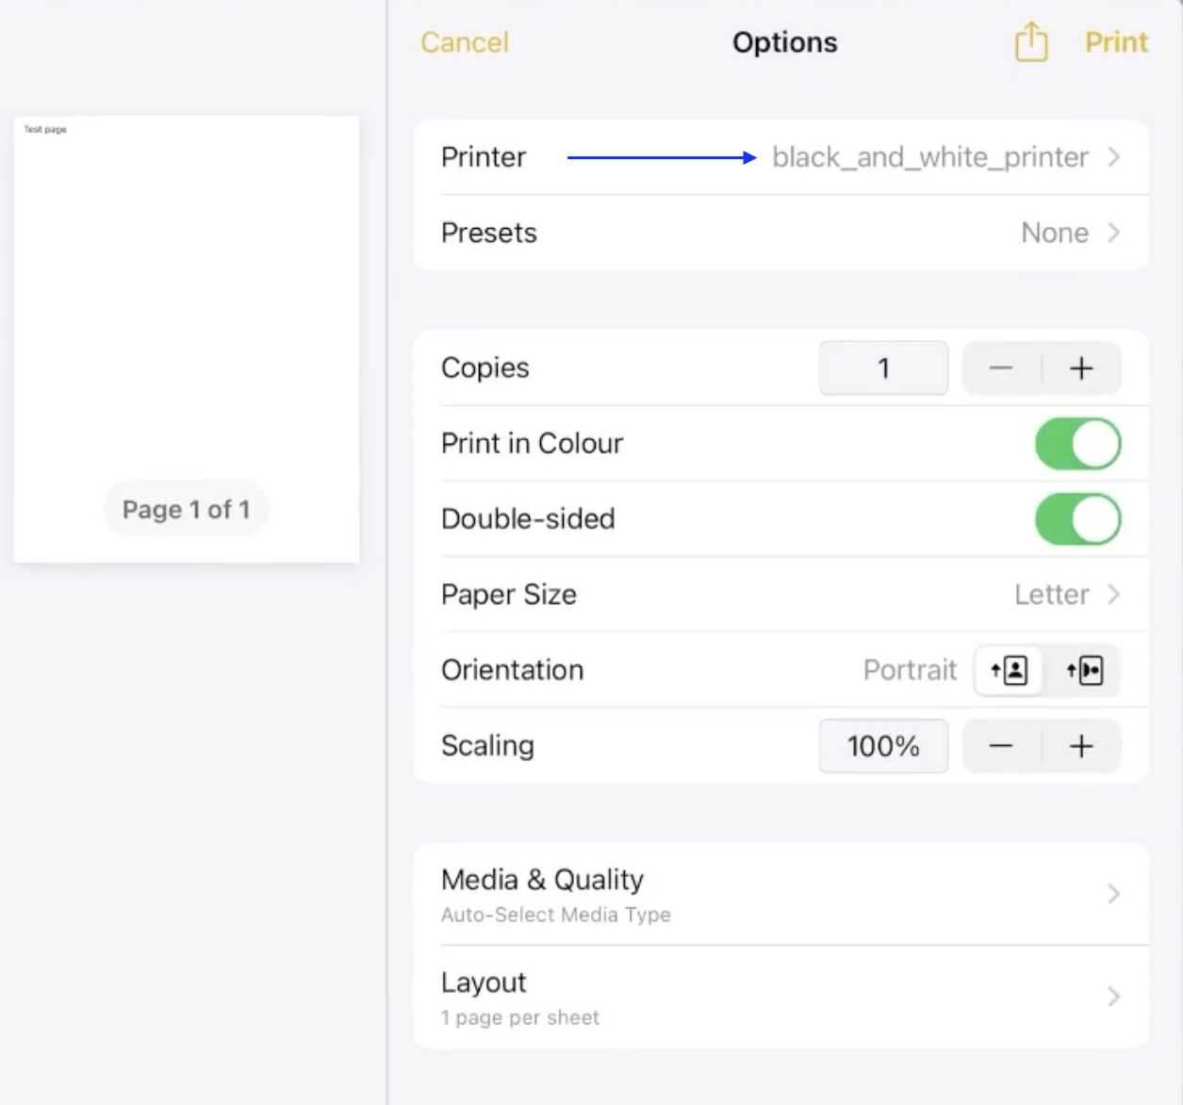

- Printers list: Select either black and white or colour.
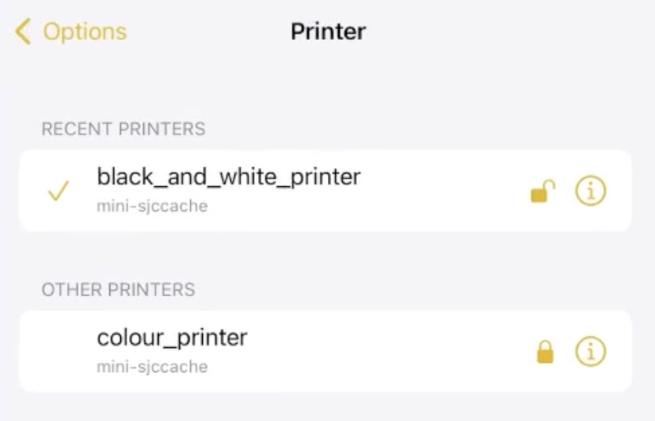

- Print button: Press print and go to printer to release documents printed.
