PRINTING LOGIN

MAC

- Open Print Deploy app: Click on View my printers
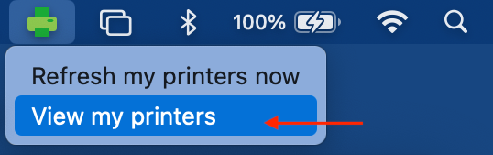

- Sign In with Microsoft: Click on Sign in with Microsoft
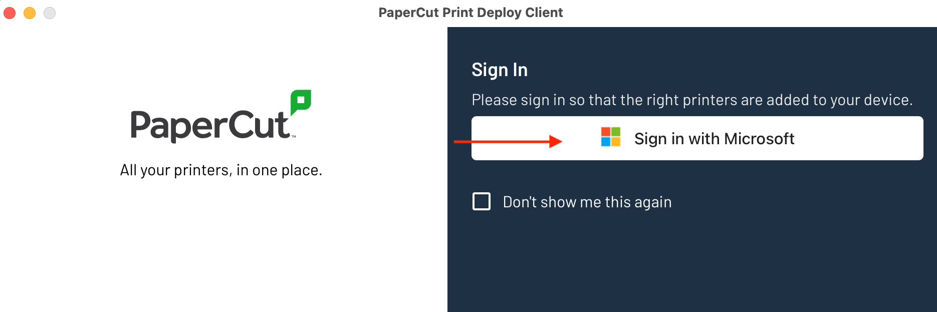

- Username: Enter your school email then click next
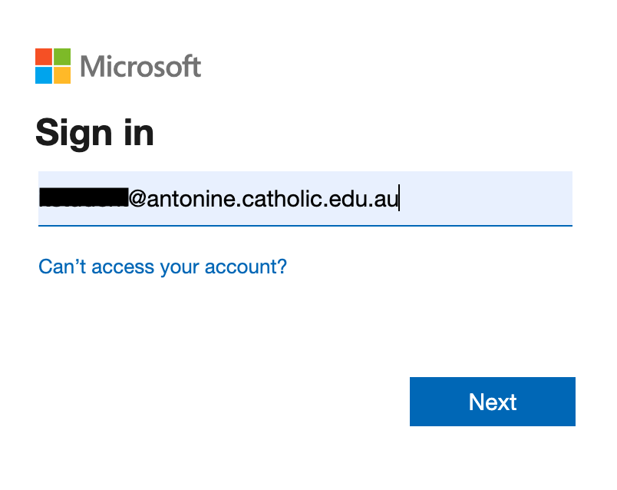

- Password: Enter your school password and click Sign in
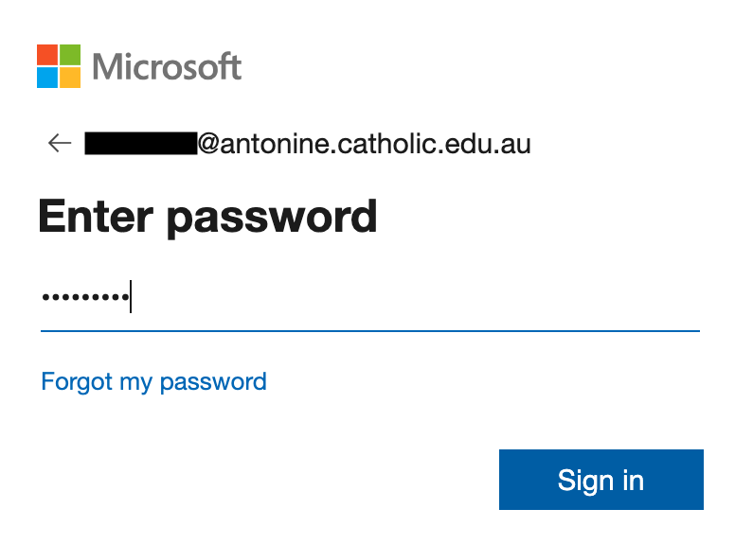

- Print Deploy app: The printing will be ready when you see this message.
