CONNECTING TO WI-FI

MAC

- Select Wi-Fi: Click  in the menu bar.

- Choose a Network: Click on STU-CONNECT to join.


- Enter your account details: Enter school username and password and click OK.

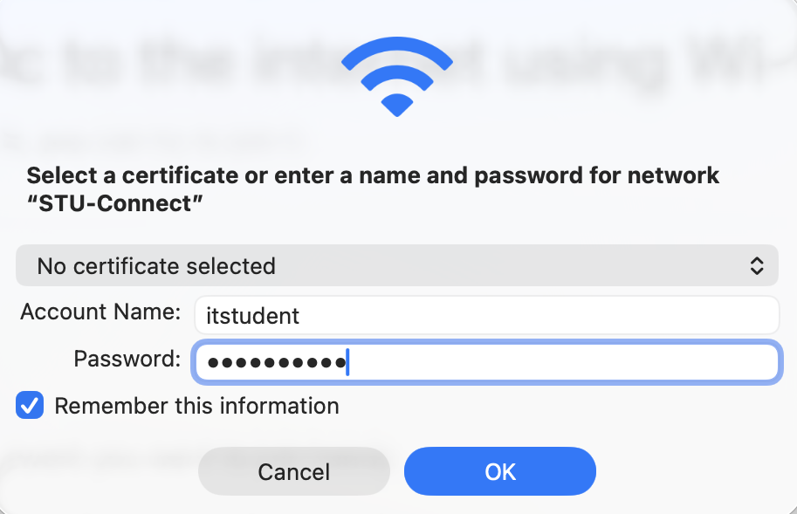

- Verify Certificate: Click Continue.

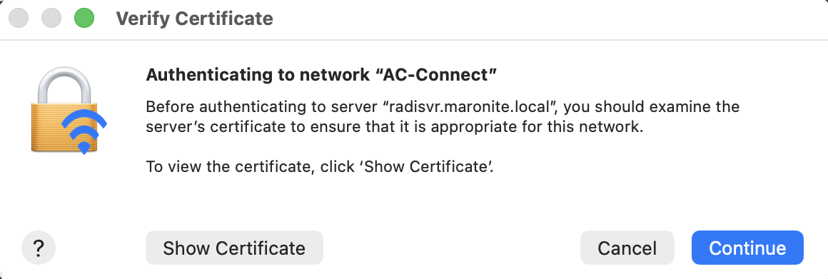

- Once the connection is successful, you'll see a blue check mark next to the network's name.



