CONNECT TO PROJECTOR

MAC

- Screen Mirroring: Click on screen mirroring

- Mirror or extend to: Click on the room number
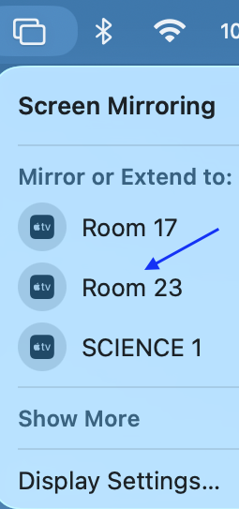

- AirPlay code: Enter the four digits code seen on the screen and will be connected successfully.

