CONNECT TO PROJECTOR

IPAD

- Screen Mirroring: Press on screen mirroring
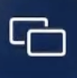
- Screen Mirroring: Select the room number
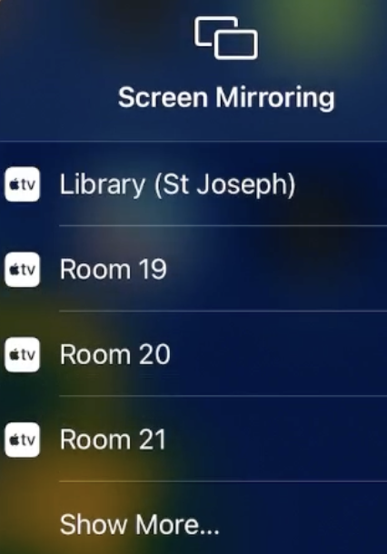

- AirPlay code: Enter the four digits code seen on the screen and will be connected successfully.

