FIND YOUR PASSWORD

MAC

- Open Keychain Access: Go to Search and look for Keychain Access app.
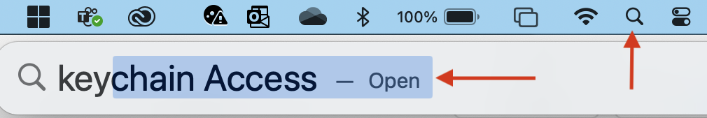

- Find Password: Use the search bar and look for STU-Connect
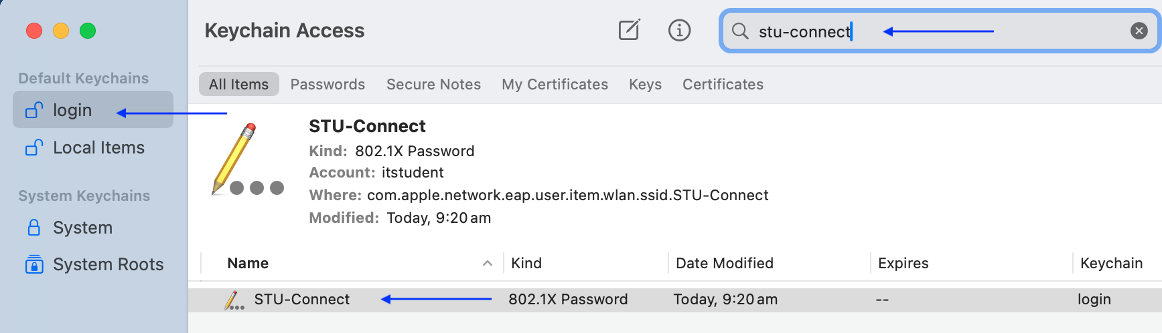

- View the Password: Double-click on STU-Connect to open its details window.
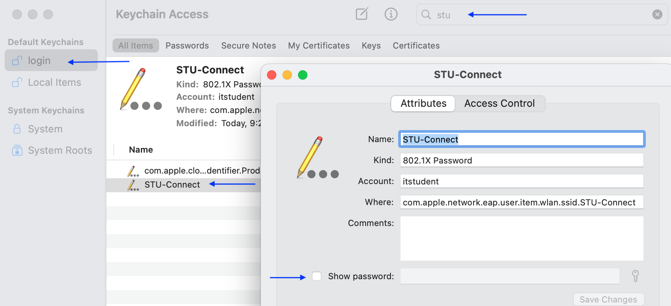

- Reveal the Password: Check the box next to "Show password" and enter your Mac's login password to show your password.
