Change Password

MAC

- Go to https://mysignins.microsoft.com/security-info/password/change

- Enter your Current password, new password then re-enter it in the confirmation field.
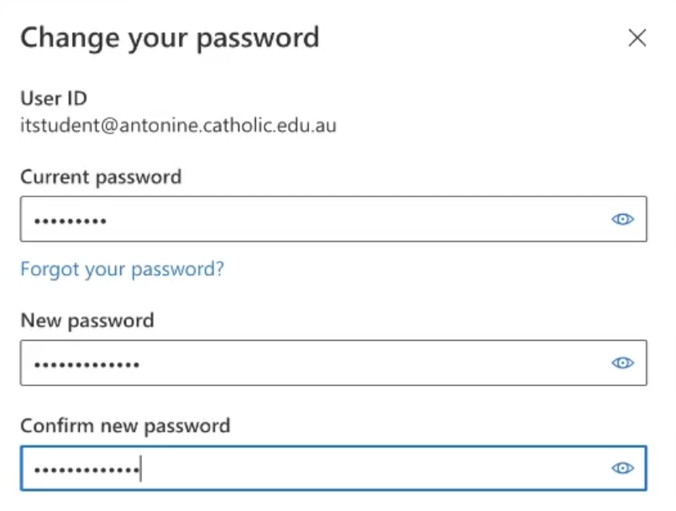
- Submit button: Click on submit button to change your password
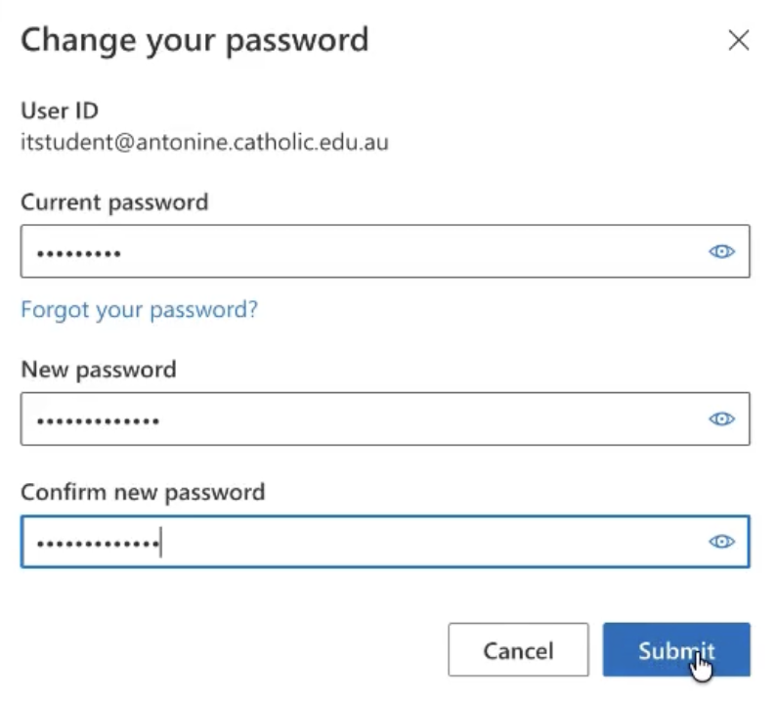

- Password changed: you will see the below message when your password has changed.
